**Conservation Treatment Report**

**Report number:** 010918 **Conservator:** Sarah Kim **Date:** 1/9/2018

**Author/Artist:** Charles Louandre

**Title:** Œuvres complètes de Molière avec des notices sur chaque comédie (Tome 1)

**Place of Publication:** Paris, France **Date of Publication:** ca. 1900

**CONDITION**

Binding: Red leather quarter binding with maroon/black/brown marbled paper; Tight back binding with headcaps; 6 panel spine with false bands, with simple flower gilding in each panels, “Oeuvres de Moliere” on second panel, “Tome 1” on third panel; Corners bumped with green vellum peeking through; front cover detached; top half of spine detached

Paper/Media: Maroon/black/brown marbled paper for covers; Beige (1) via Print Council of America text block

Sewing: 4 cord binding

Endpapers: Blue with yellow and red crackling marbled endpapers

Forwarding: Thin green ribbon bookmark fraying; Faded red sprinkled fore-edges; red and yellow stuck on headbands

Photo documentation: 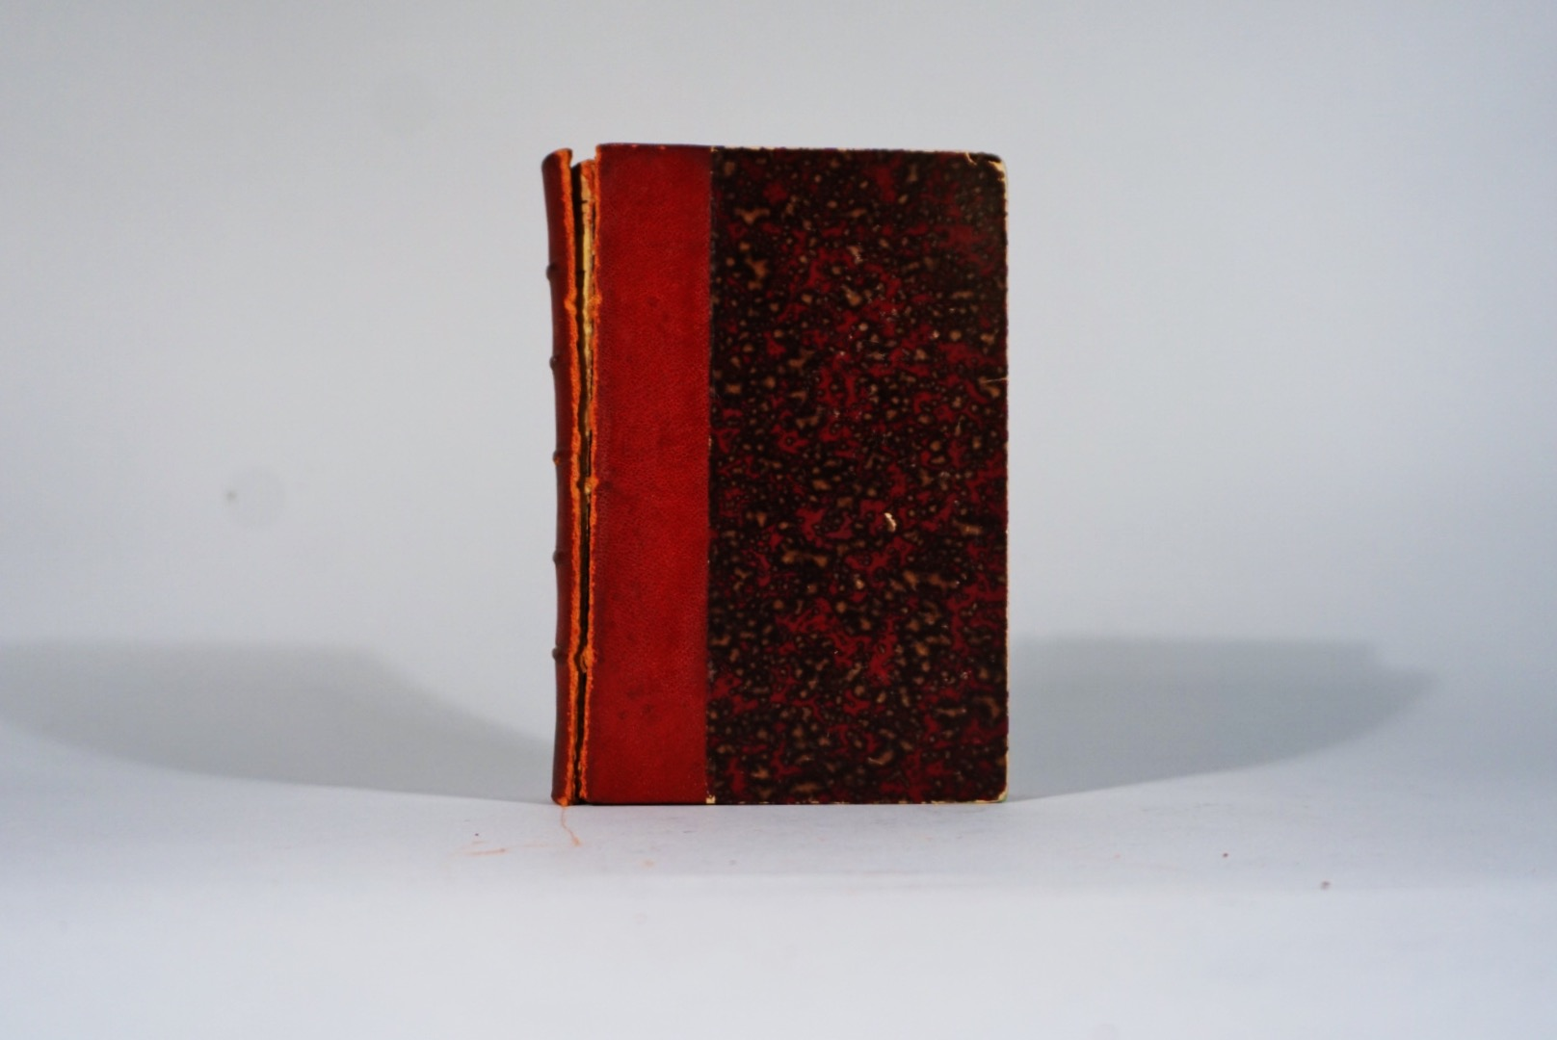

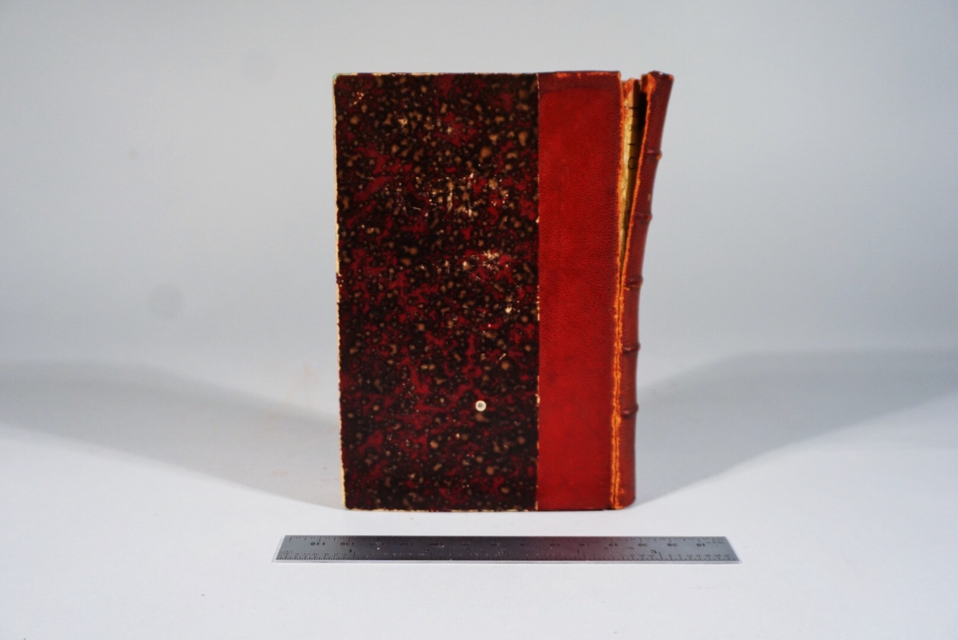

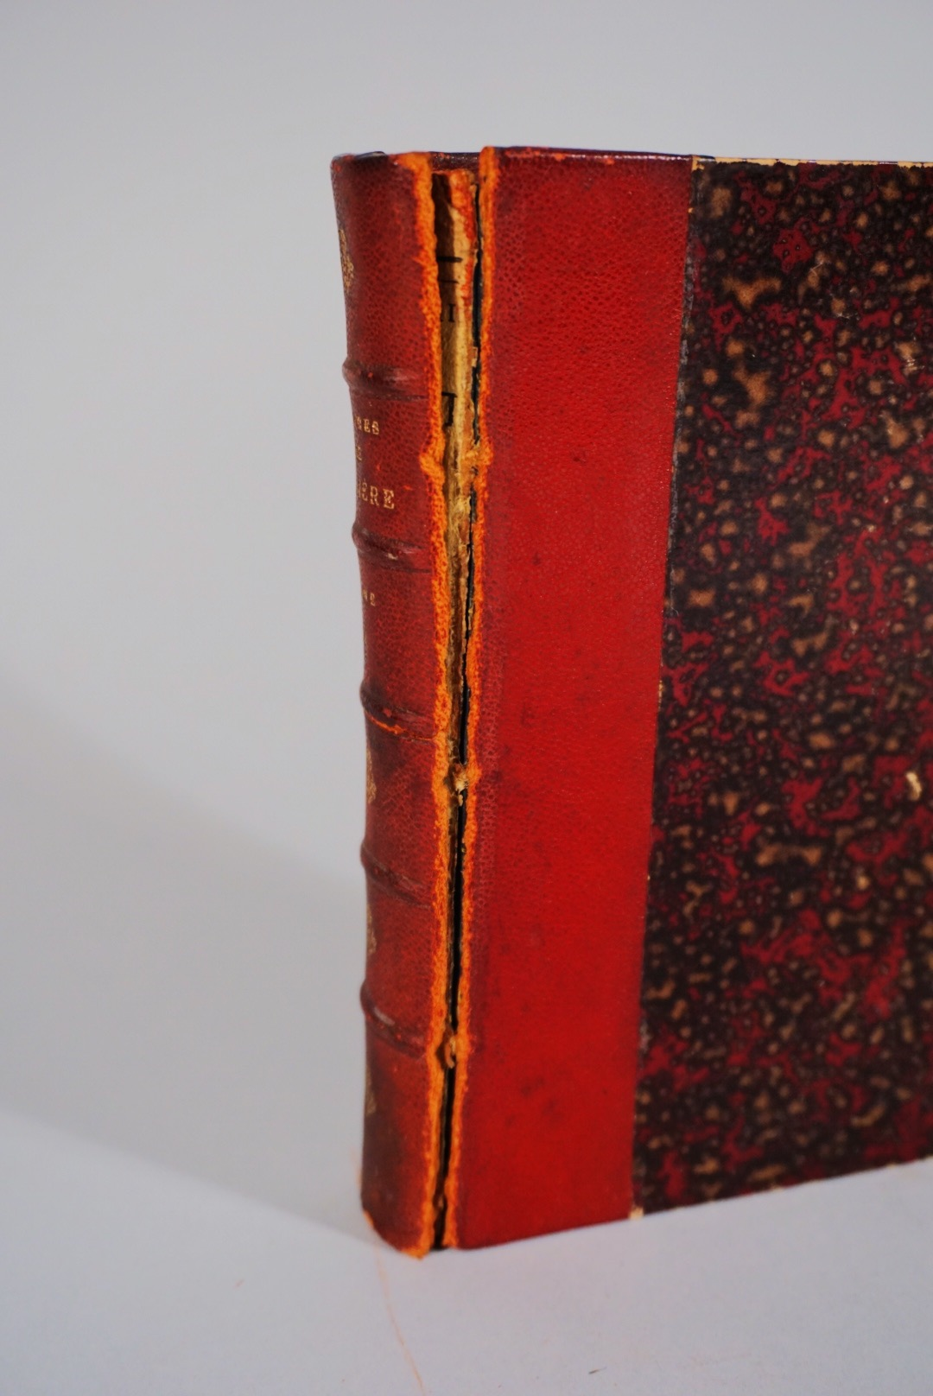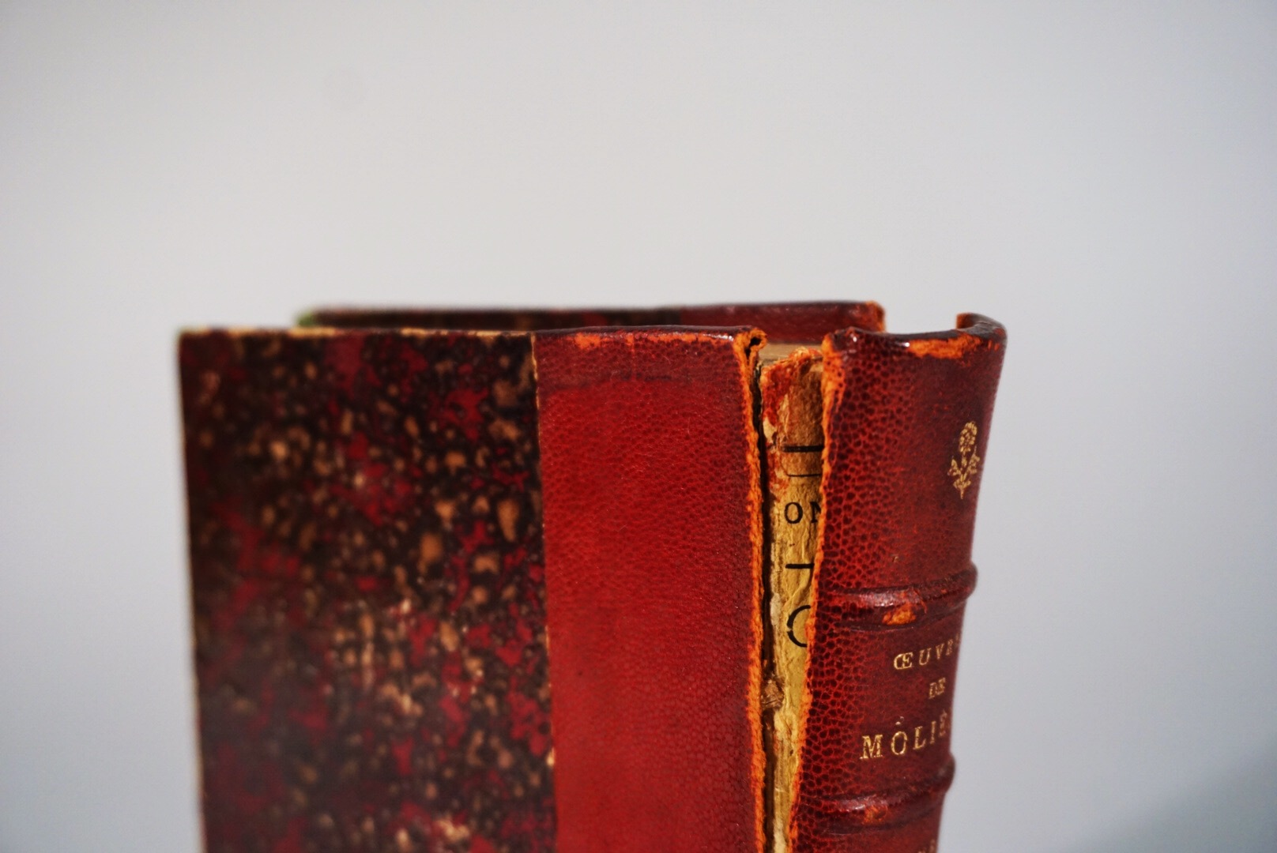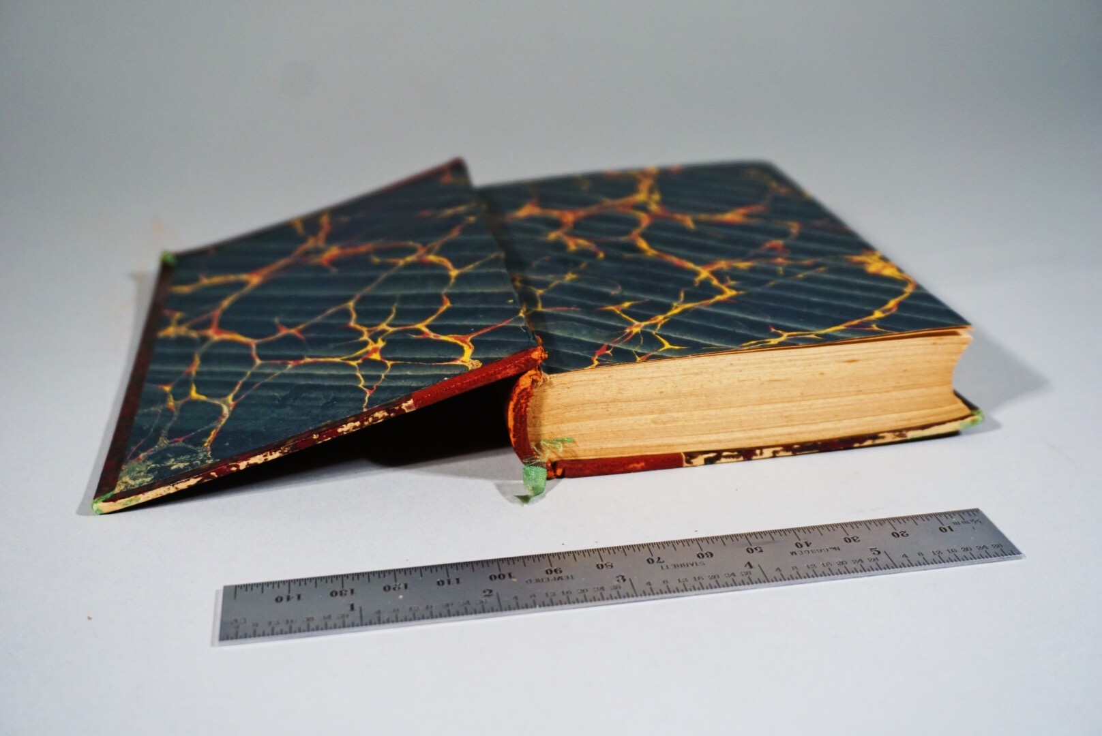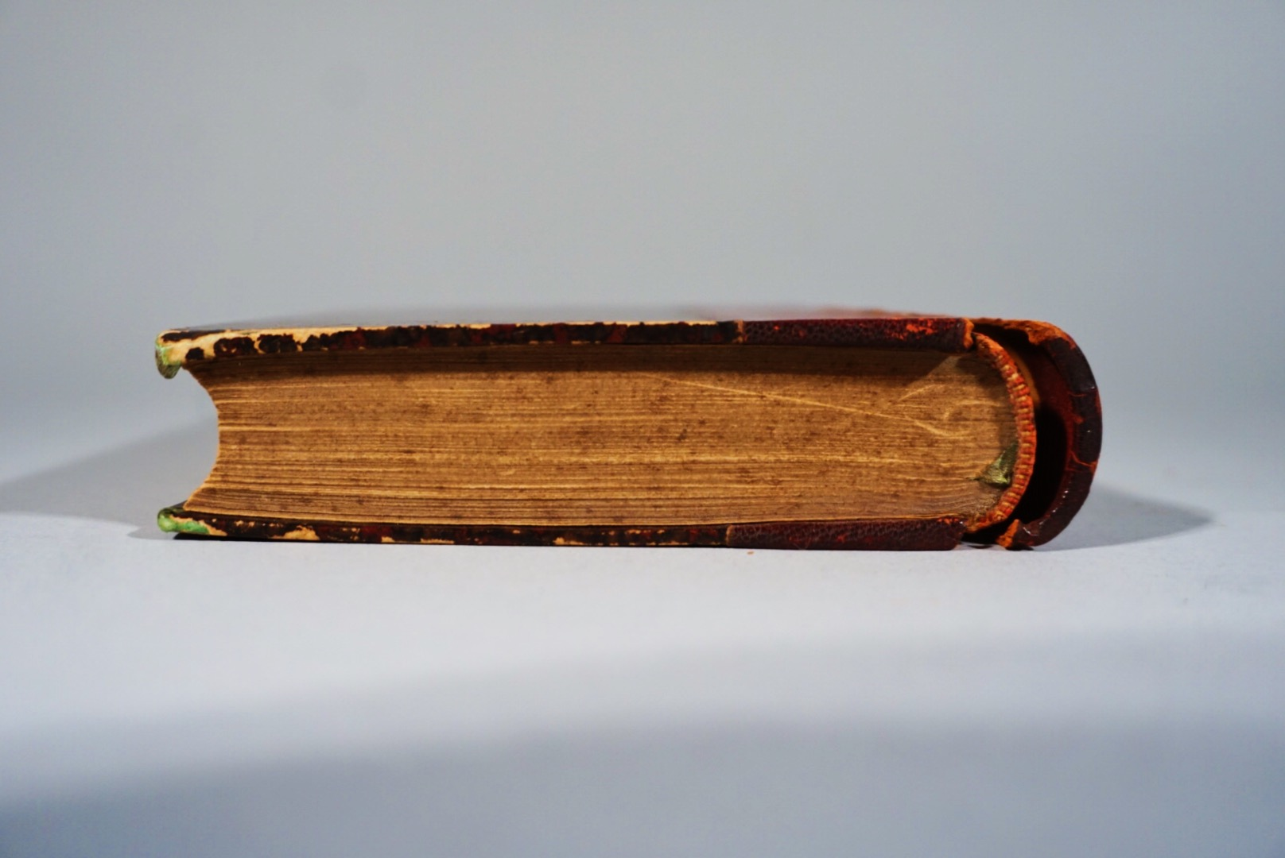

TREATMENT

Spot tests:

2% Klucel-G consolidant

Red rot cocktail

Staining: aniline dye on calf - 1 part #9 red: 1 part #8 bordeaux: ⅛ part #1 brown

Binding:

Heat set tissue on spine piece: applied with isopropyl on brush. Corner repair using watered down wheat paste (aytex-p) and applied with syringe, dried under control between ree-may and boards. Manually removed paper lining under the spine with tweezers. Poulticed old spine lining with SCMC (4%) to clean spine. Lined clean spine with medium weight Sekishu tissue. Toned medium weight Sekishu tissue with Golden acrylics to match the dark blue endpapers, glued onto shoulders of the textblock. Pasted on first layer of extended paper lining using Okawara tissue to tuck under the paste down of the front board, added another extended lining to tuck under the lifted leather. Covered spine with dyed leather using wheat paste and left to dry overnight. Took original spine that was covered with heat set tissue and gently beveled off edges of paper lining with a dremel. Applied the original spine onto the covered spine using PVA, left to dry wrapped in ace bandage. Once dried, applied isopropyl with brush onto the heat set tissue to reactive adhesive, and using tweezers to gently peel back the tissue. Toned the old leather edges of the original spine with Golden acrylics to better match and blend to the new leather.

Photodocumentation:

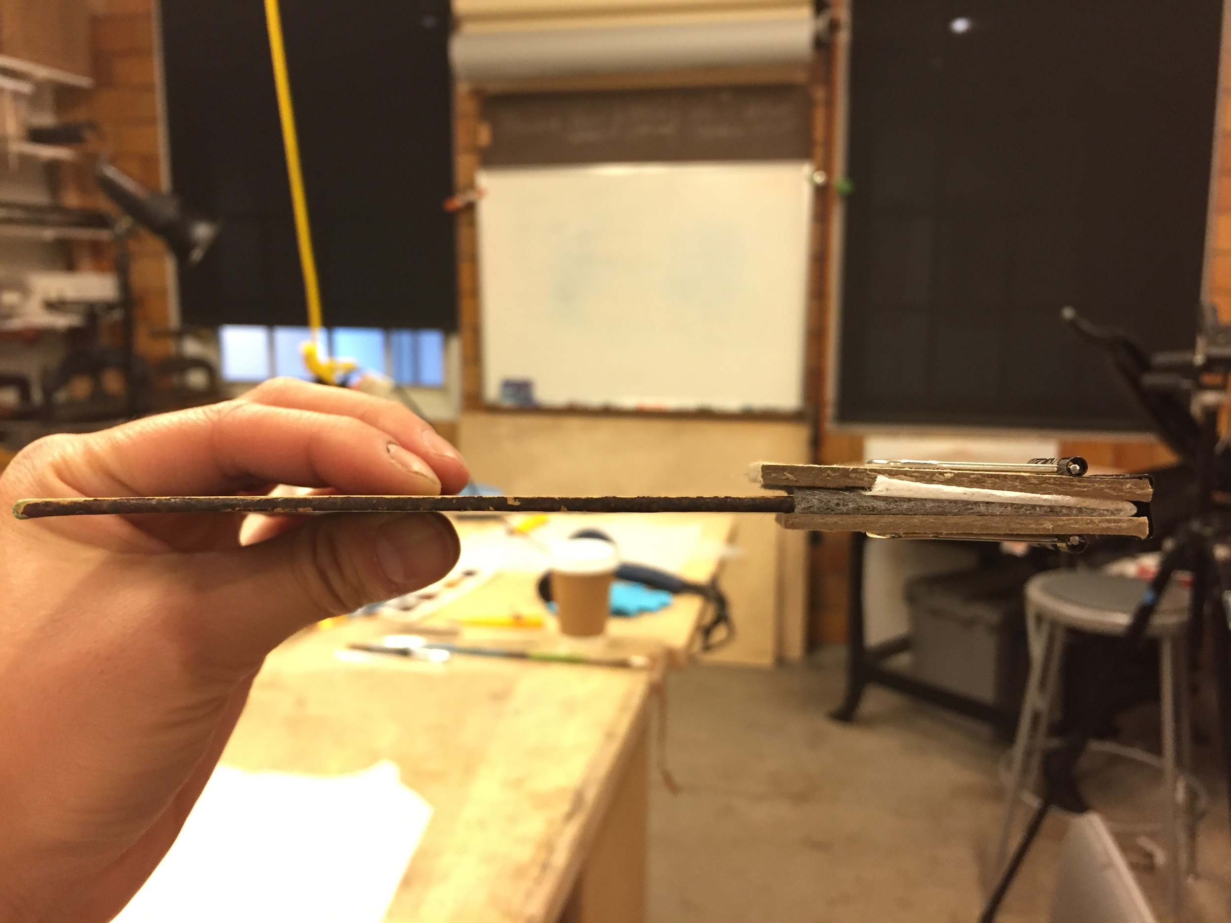

Corner repair

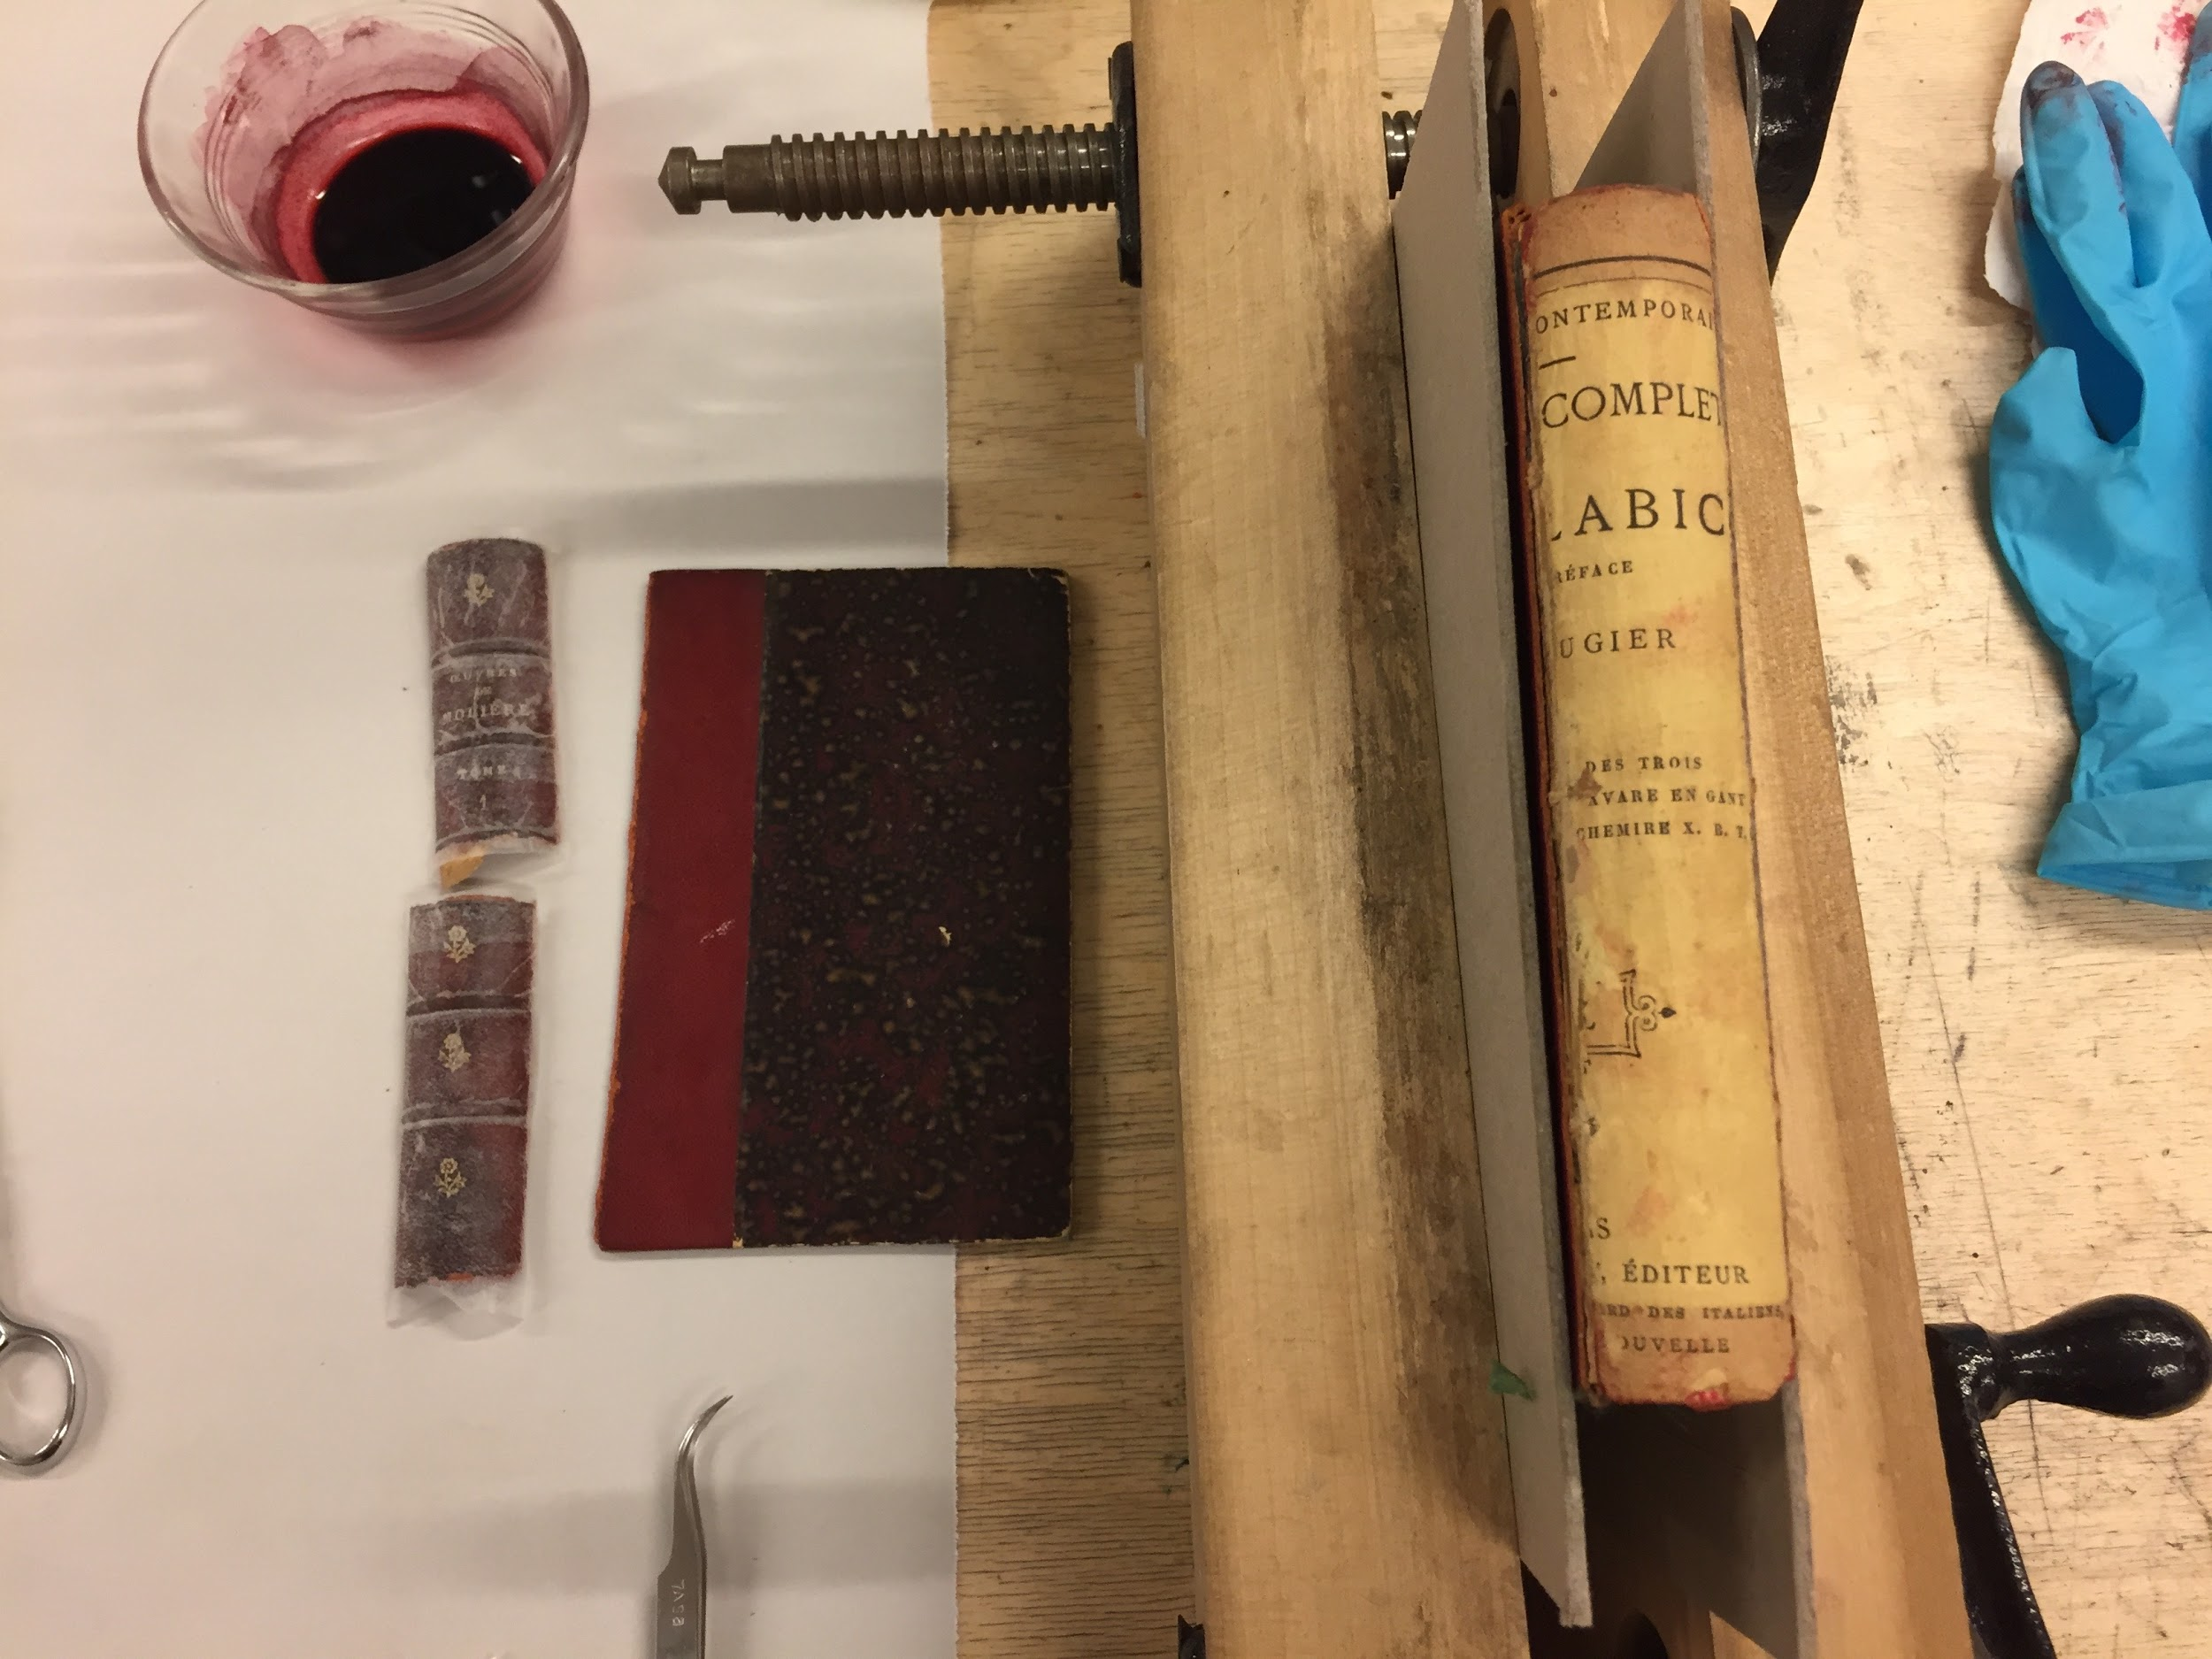

Heat set tissue on original spine

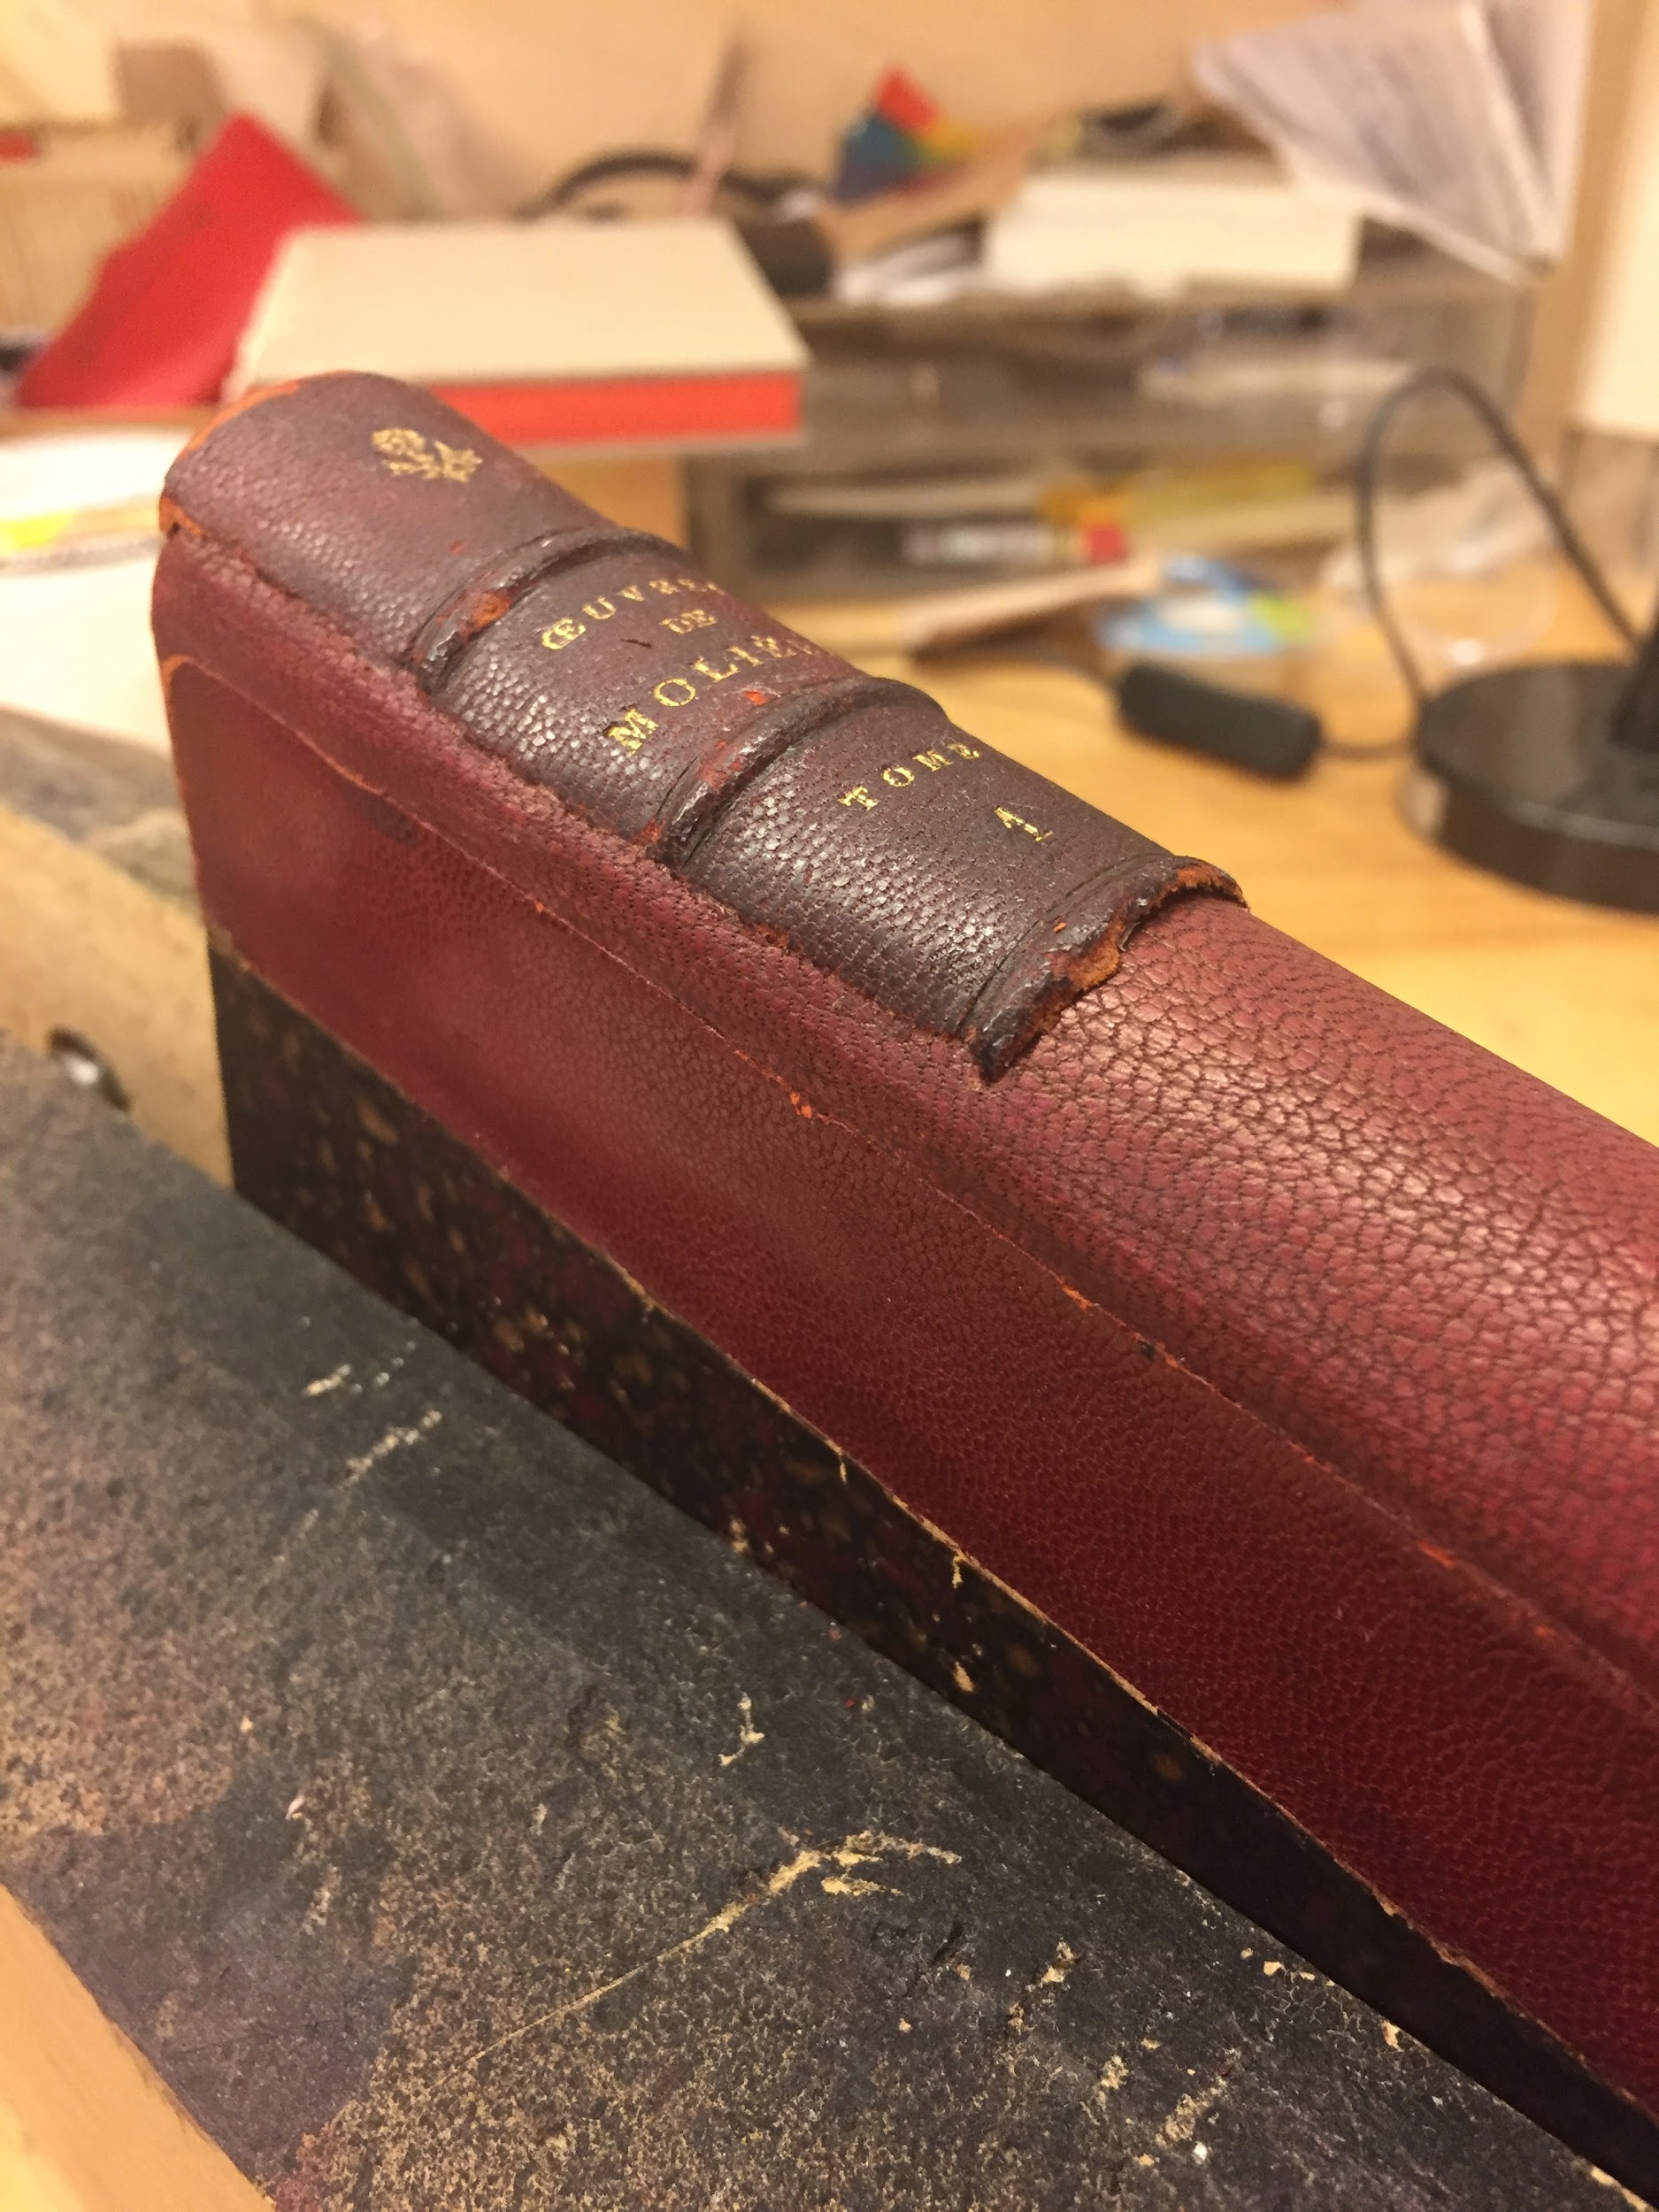

Original spine glued onto new spine

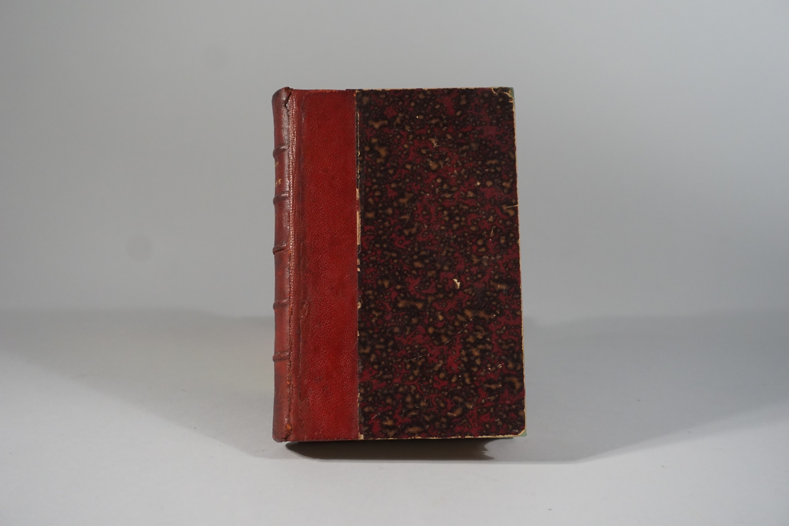

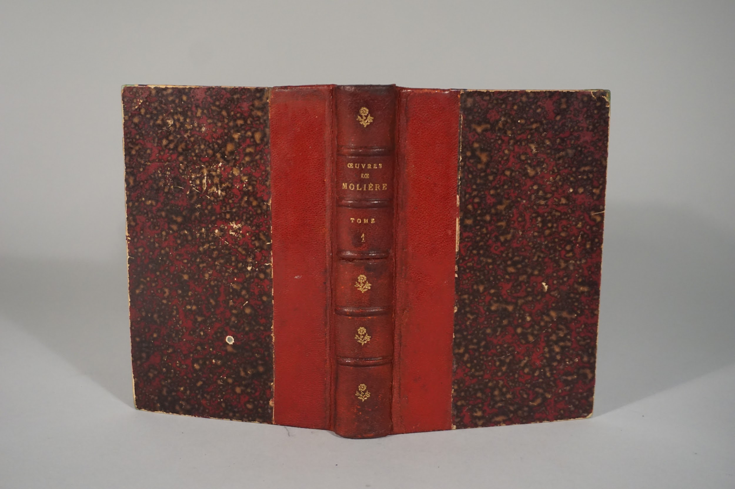

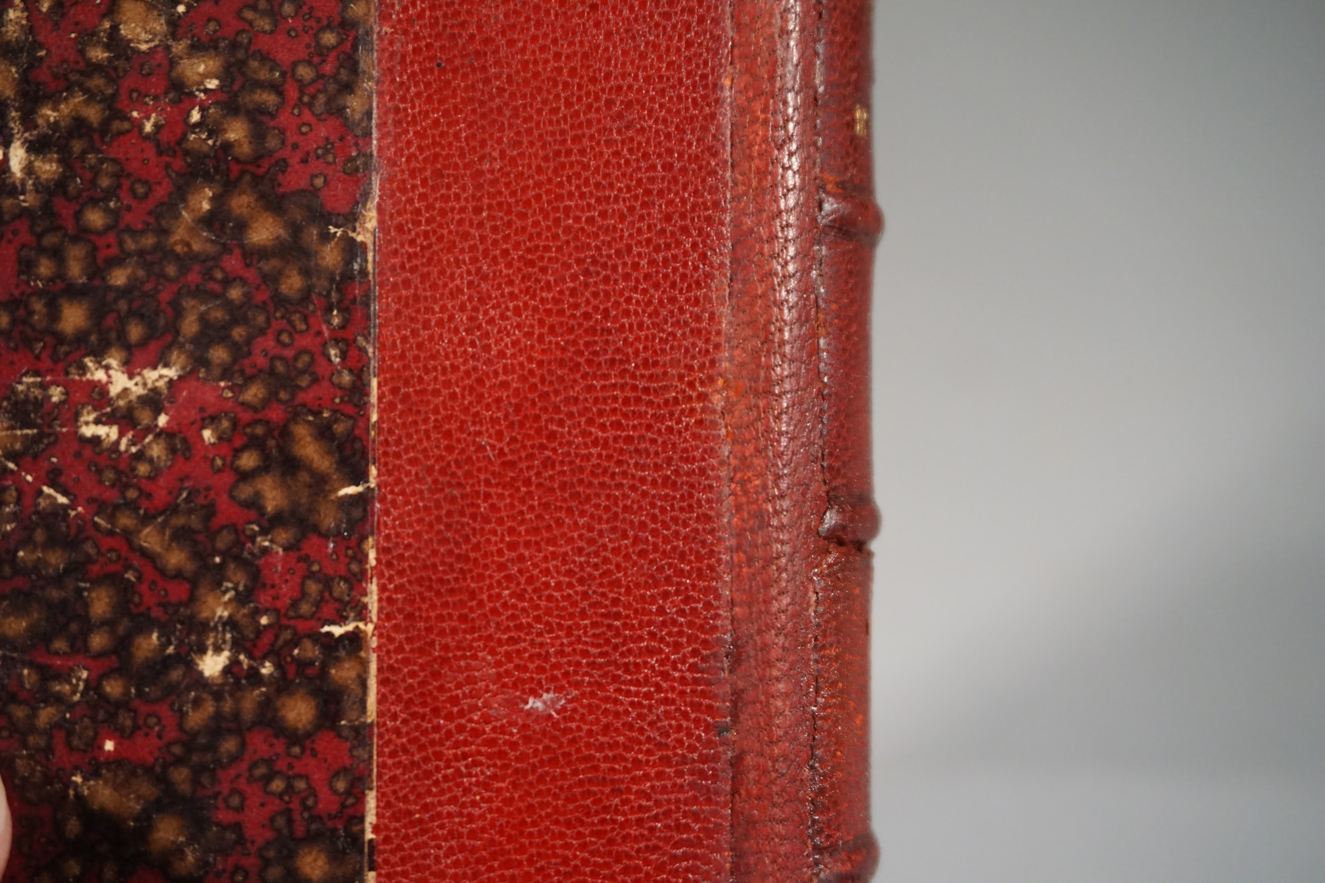

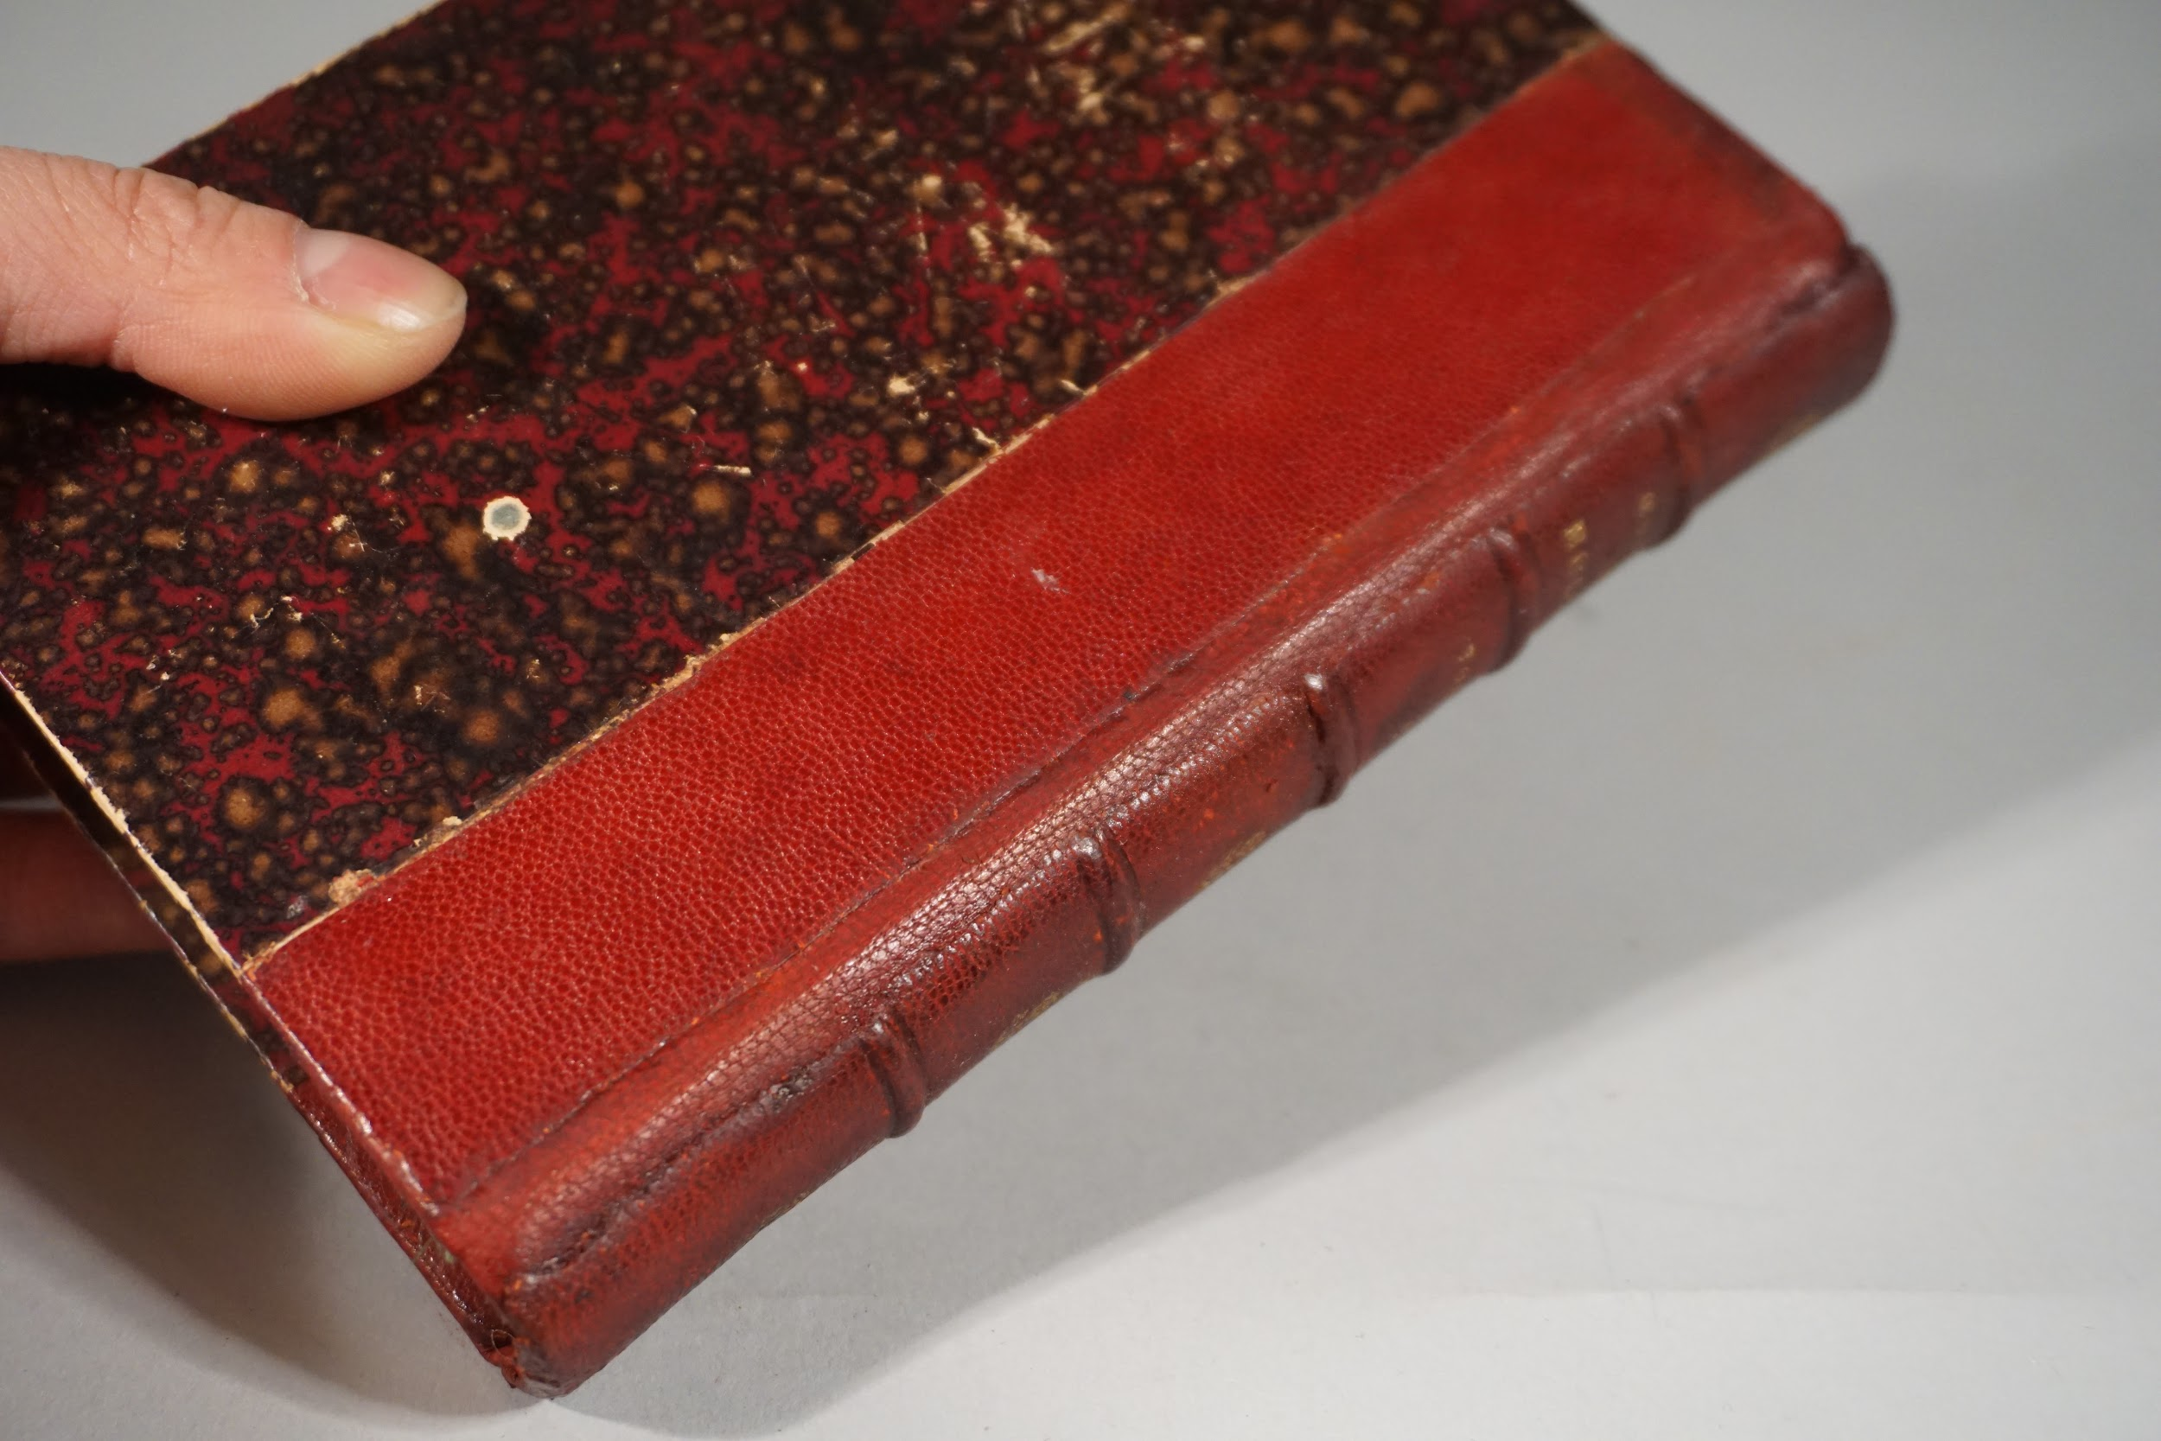

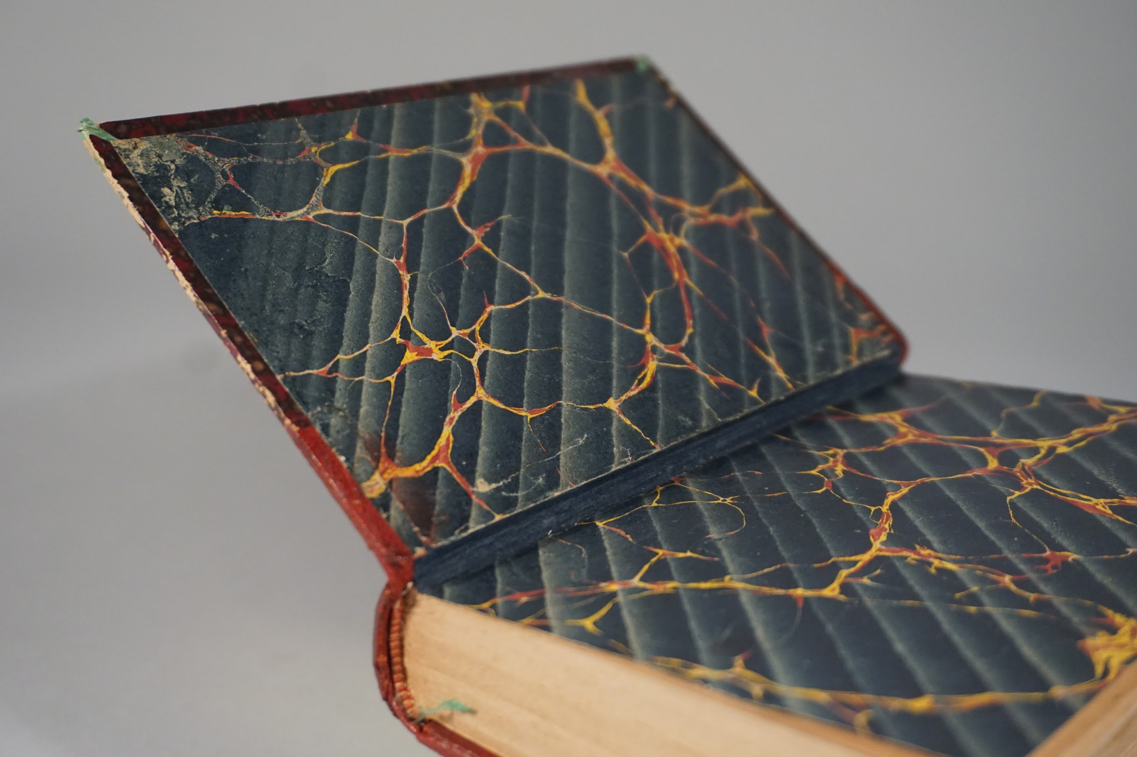

Date completed: January 29, 2018